

APDS7311 ICE TASK 3

Eben Mwema, ST10091324



BCA701

GROUP 1

VC WATERFALL

1.First download the ssl certificate

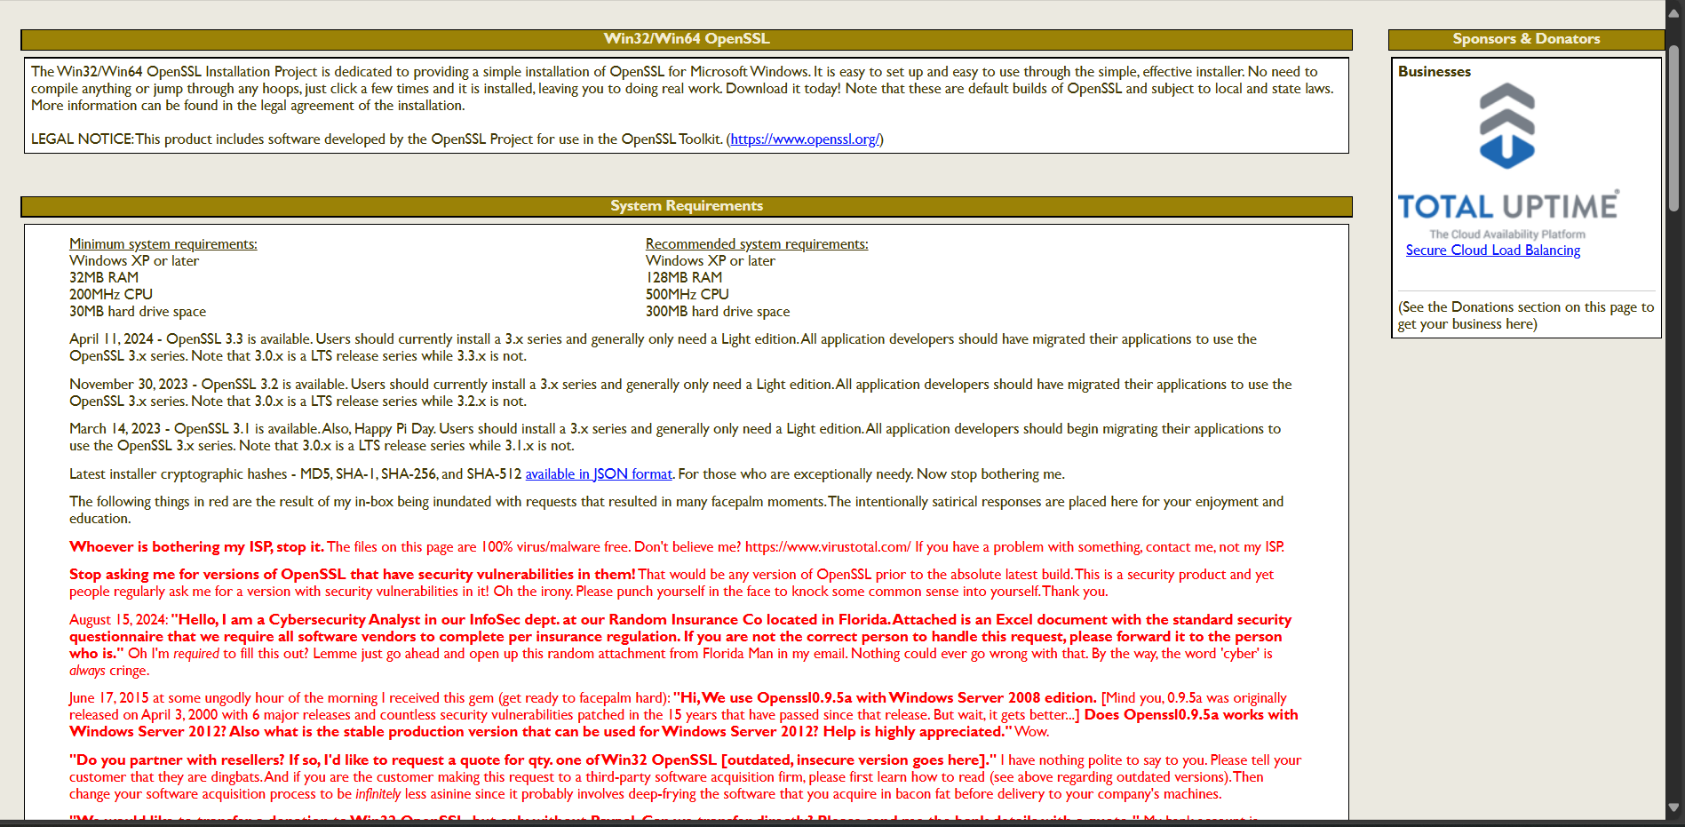

Figure 1: SSL Certificate Download

2. Accept all the changes and put it in the bin directory

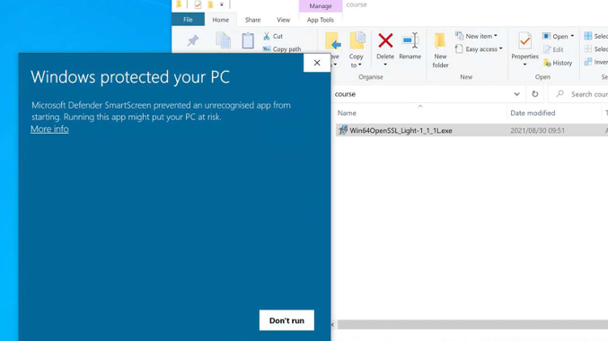

Figure 2: Permission Popup

3. Then copy and paste the key to your keys folder

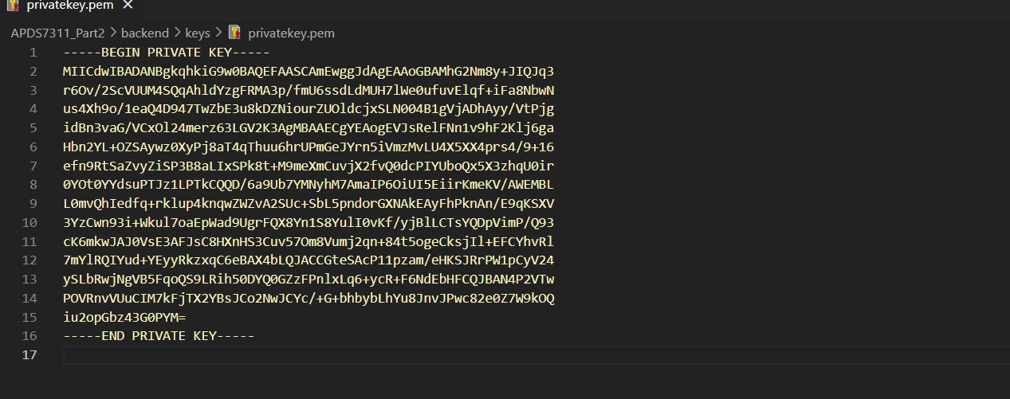

Figure 3: Key Generation